High Level Architechture

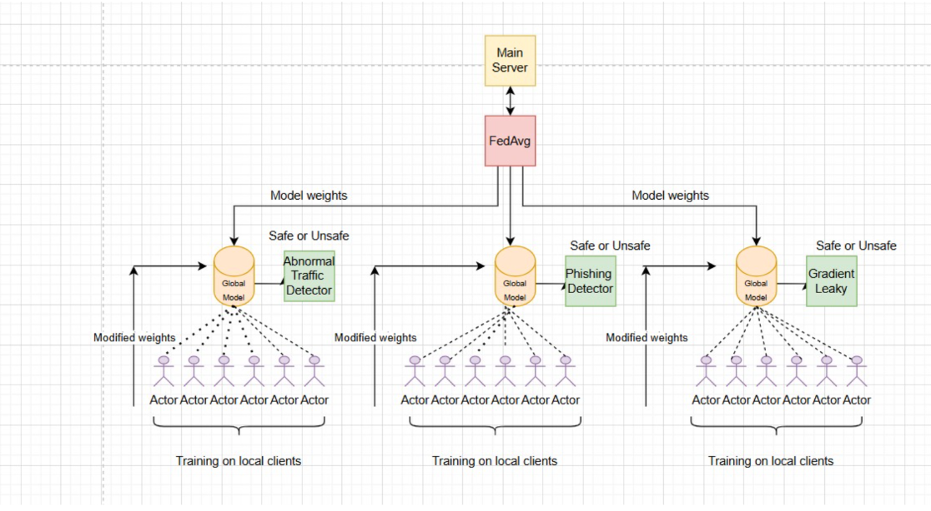

The proposed system adopts a federated learning-based distributed architecture comprising multiple client devices and a centralized aggregation server. As shown in the figure, the framework is organized into three parallel threat detection pipelines: abnormal network traffic detection, phishing detection, and gradient leakage analysis.

At the client level, multiple participants independently train local models on their private datasets. Raw data is not shared; instead, only locally updated model parameters are transmitted to the central server, preserving data confidentiality.

At the server side, the received model updates are aggregated to form a global model. Although represented as FedAvg in the figure, the implementation employs a combination of FedProx and momentum-based FedAvg++ to improve convergence stability under non-IID data distributions. The updated global model is then redistributed to all clients for subsequent training rounds.

Each detection pipeline maintains a dedicated global model: the abnormal traffic detector identifies anomalous network behavior, the phishing detector classifies malicious inputs, and the gradient leakage module evaluates potential privacy risks. Each module produces a binary SAFE/UNSAFE decision based on aggregated knowledge.

Overall, the architecture enables collaborative learning across distributed clients while maintaining data privacy, and supports scalable, multi-task cybersecurity threat detection.

Diagram

System Model
Consider a federated learning system consisting of 6 distributed clients and a central server. Each client i∈{1,2,...,6}i∈{1,2,...,6} possesses a local dataset DiDi​, which remains private and is not shared with other clients or the server.
The objective is to collaboratively train a global model ww by minimizing the overall loss across all clients:
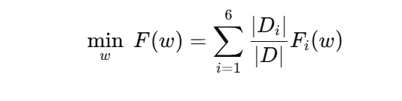
where:
- Fi(w)Fi​(w) is the local loss function at client ii
- ∣Di∣∣Di​∣ is the size of local dataset
- ∣D∣=∑i=1N∣Di∣∣D∣=∑i=1N​∣Di​∣

Local Training (Client-Side Update)
Each client updates the global model locally using its dataset:

where:
- Wt:wt is the global model at round tt
- η:η is the learning rate
- ∇Fi(wt):∇Fi​(wt) is the gradient computed on local data
In the case of FedProx, a proximal term is added to stabilize updates under non-IID data:
Fiprox(w)=Fi(w)+μ2∥w−wt∥2Fiprox​(w)=Fi​(w)+2μ​∥w−wt∥2
where:
- μ:μ controls the strength of regularization

Server Aggregation (FedAvg++)
After local training, clients send updated weights wit+1wit+1​ to the server. The server computes the average update:
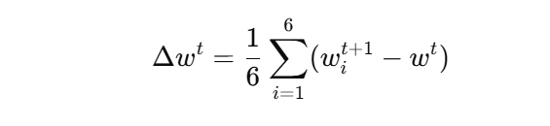
FedAvg++ introduces a momentum-based update:
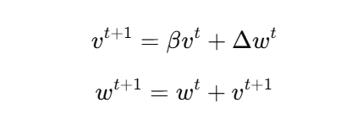
where:
- vtvt is the velocity term
- β∈[0,1]β∈[0,1] is the momentum factor

Multi-Task Learning Setup
The system maintains three independent global models:
- w(1)w(1): Phishing detection
- w(2)w(2): Network traffic anomaly detection
- w(3)w(3): Gradient leakage analysis
Each model is trained using the same federated optimization process but on different datasets.

Final Decision Function
The outputs from phishing and traffic models are combined:
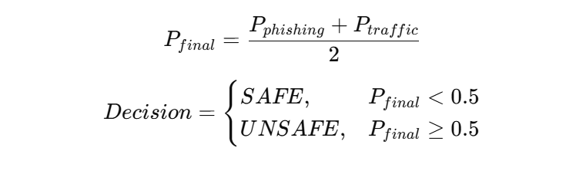

Data descrption and preprocessing

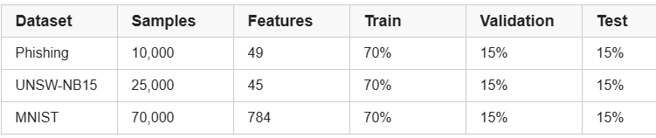

The proposed framework utilizes multiple datasets corresponding to different cybersecurity threat detection tasks, namely phishing detection, network traffic anomaly detection, and gradient leakage analysis. Each dataset is independently processed and distributed across six federated clients, ensuring that raw data remains localized.
For phishing detection, a dataset obtained from Kaggle is employed, consisting of approximately 10,000 samples with 49 features, representing various characteristics of URLs and web-based attributes. The dataset is preprocessed by handling missing values, encoding categorical features, and normalizing numerical attributes to ensure uniform input representation for the learning model.
For network traffic analysis, the UNSW-NB15 dataset is used, containing approximately 25,000 samples with 45 features that describe network flow characteristics. Preprocessing steps include removal of redundant attributes, feature scaling, and conversion of categorical variables into numerical form to facilitate effective training under heterogeneous client environments.
For gradient leakage analysis, the MNIST dataset is utilized as a benchmark dataset to simulate gradient-based privacy risks. The dataset consists of grayscale images, which are normalized and reshaped appropriately before being used for model training.
Following preprocessing, each dataset is partitioned and distributed across the six clients in a non-IID manner to reflect realistic decentralized scenarios. Local preprocessing is performed at each client to maintain data privacy. The processed data is then used to train task-specific neural network models within the federated learning framework

2. Dataset Description
The methodology utilizes three distinct datasets, each aligned with a specific threat detection task:
- Phishing Dataset:
A structured dataset containing URL-based features such as domain characteristics, hyperlink behavior, and security indicators. It consists of 10,000 samples with 49 features after preprocessing, labeled as legitimate or phishing.
- Abnormal Network Traffic Dataset:
A network intrusion dataset comprising traffic flow features such as packet counts, byte rates, protocol types, and connection states. The dataset is downsampled to 25,000 records and used for binary classification (normal vs abnormal traffic).
- MNIST Dataset (Gradient Analysis):
The MNIST handwritten digit dataset is used as a proxy to analyze gradient behavior and potential leakage. It contains 70,000 grayscale images (28×28), flattened into 784-dimensional feature vectors and categorized into 10 classes.

3. Data Preprocessing

Data processing pipeline

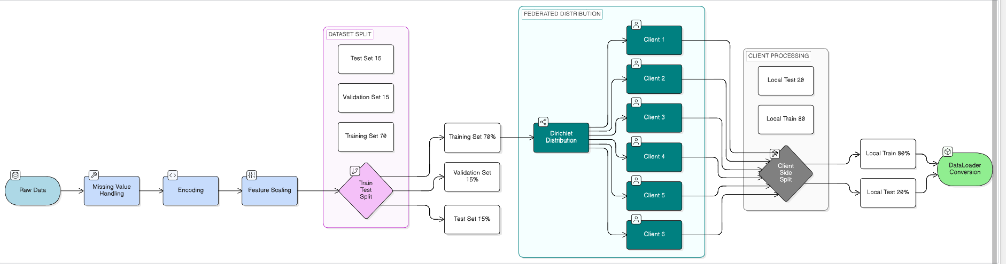

Step 1: Raw Data Acquisition
The process begins with the collection of raw data from multiple sources corresponding to phishing detection, network traffic analysis, and gradient leakage evaluation. These datasets may contain inconsistencies, missing values, and heterogeneous feature formats.

Step 2: Missing Value Handling
To ensure data quality, missing values in numerical features are handled using mean imputation. Additionally, features with excessive missing values (greater than 30%) are removed to prevent noise and bias in model training.

Step 3: Feature Encoding
Categorical attributes present in the dataset are transformed into numerical representations using label encoding. This step ensures compatibility with neural network models, which require numerical input.

Step 4: Feature Scaling
All numerical features are standardized using a Standard Scaler, ensuring that the data follows a uniform distribution. This improves convergence speed and stability during training.

Step 5: Global Data Splitting (Server-Side)
The processed dataset is split at the server level into:
- 70% Training Data
- 15% Validation Data
- 15% Testing Data
Stratified sampling is applied to maintain class balance across all subsets

Step 6: Federated Distribution (Dirichlet-Based Non-IID Split)
The training dataset is distributed among six clients using a Dirichlet distribution. This introduces statistical heterogeneity, ensuring that each client receives a unique and imbalanced subset of data, thereby simulating realistic non-IID conditions.

Step 7: Client-Side Data Splitting
Each client further partitions its local dataset into:
- 80% Local Training Data
- 20% Local Testing Data

To ensure consistency, robustness, and effective model performance across distributed environments, a structured preprocessing pipeline is employed.
Initially, missing values in the datasets are handled by applying mean imputation for numerical features, while features with excessive missing data (greater than 30%) are removed to maintain data quality. For datasets containing categorical attributes, label encoding is applied to convert them into numerical form suitable for neural network processing.
Subsequently, all numerical features are normalized using standardization (Standard Scaler) to ensure uniform feature distribution and stable model convergence during training.
At the server level, each dataset is divided using a 70:30 split, where 30% of the data is further equally partitioned into validation (15%) and testing (15%) subsets. Stratified sampling is applied during splitting to preserve class distribution across all subsets.
To simulate realistic federated learning conditions, the training data is distributed among six clients using a Dirichlet-based partitioning strategy, thereby introducing non-identically distributed (non-IID) data characteristics across clients.
At the client level, each local dataset is further split into training and testing sets using an 80:20 ratio, enabling independent evaluation of local model performance. The processed data is then converted into tensor format and organized into mini-batches using data loaders to support efficient batch-wise training.

Step 8: DataLoader and Tensor Conversion
Finally, the processed datasets are converted into tensor format and organized into mini-batches using data loaders, enabling efficient batch-wise training in the federated learning framework.

4. Data Preprocessing Results

Phishing

Class Distribution:

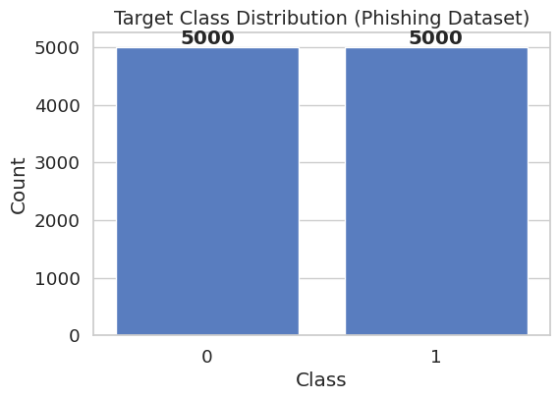

Abnormal traffic:

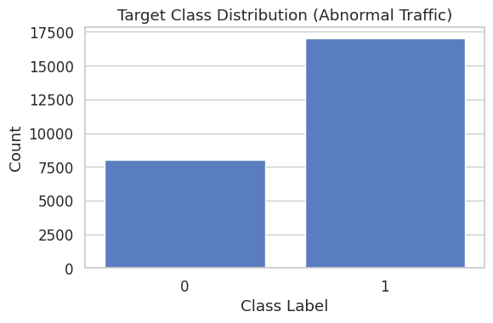

Mnist Dataset

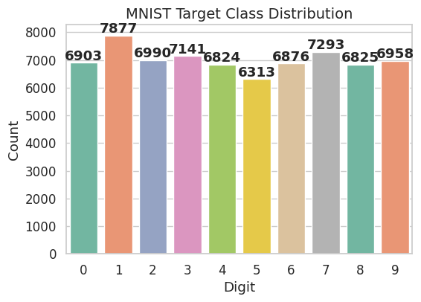

Feature Correlation Map

Phishing Dataset

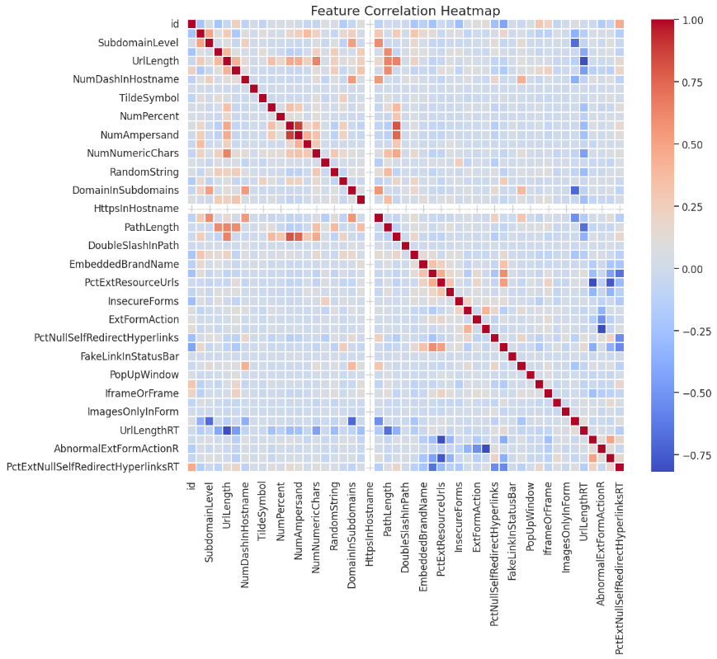

Abnormal Dataset
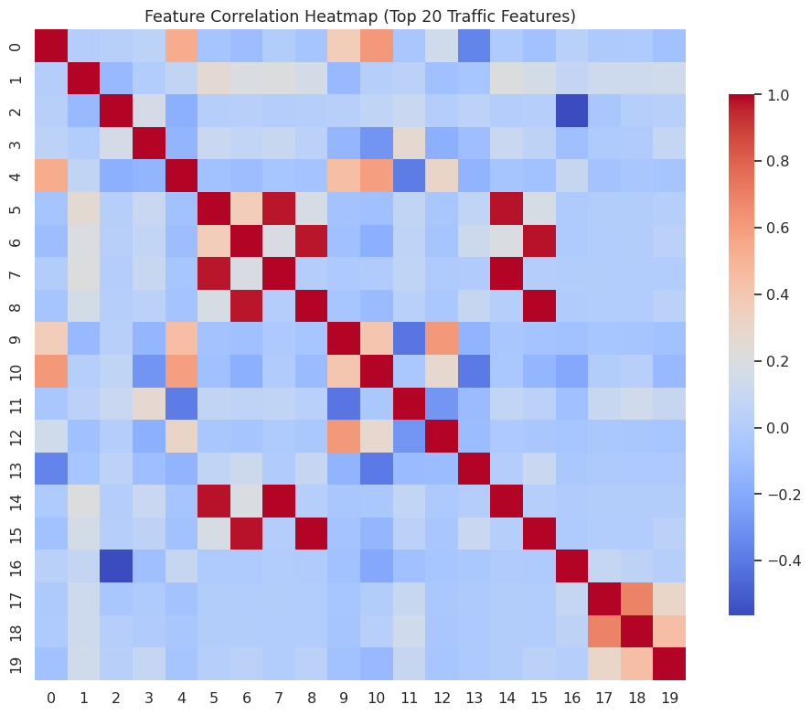

4. Detailed Implementation

4.1 Federated Learning Setup
The proposed system adopts a federated learning paradigm involving six distributed clients (N = 6) to simulate a decentralized environment. Each client holds a local subset of data and participates in collaborative model training without sharing raw data, thereby preserving data privacy.
To emulate realistic non-IID data distributions, a Dirichlet-based partitioning strategy is employed. Specifically, for each class cc, the data samples are distributed across clients according to:
pc∼Dirichlet(α)pc​∼Dirichlet(α)
where α=0.2α=0.2 controls the level of heterogeneity. Smaller values of αα result in highly skewed class distributions across clients, effectively simulating real-world federated scenarios.

4.2 Client Data Preparation and Loaders
Each client dataset is further split into training and local testing subsets using an 80:20 ratio. The implementation leverages TensorFlow’s tf.data.Dataset pipeline for efficient data handling:
- Training data is shuffled and batched.
- Testing data is batched without shuffling.
- Batch size is kept consistent across clients.
This ensures uniform training conditions and reproducibility across all participating clients.

4.3 Neural Network Architecture
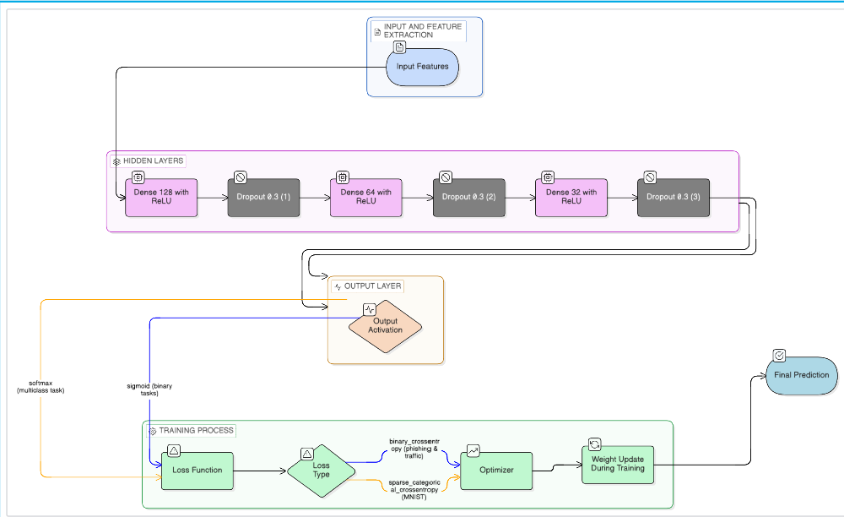
A unified fully connected deep neural network is used as the global model across all tasks. The architecture is defined as follows:
- Input layer: size = feature dimension
- Hidden layers:
  - Dense (128 units, ReLU) + Dropout (0.3)
  - Dense (64 units, ReLU) + Dropout (0.3)
  - Dense (32 units, ReLU) + Dropout (0.3)
  - Dense (16 units, ReLU) + Dropout (0.3)
- Output layer:
  - Sigmoid activation for binary classification tasks (phishing, network traffic)
  - Softmax activation for multi-class classification (MNIST)

Loss Functions:
- Binary tasks: Binary Cross-Entropy
- Multi-class task: Sparse Categorical Cross-Entropy

Optimization:
- Optimizer: Adam
- Learning rate: 1×10−41×10−4

4.4 Federated Optimization Algorithms

4.4.1 FedAvg++ (Momentum-based Aggregation)
The system extends the traditional Federated Averaging (FedAvg) algorithm by incorporating momentum-based updates, referred to as FedAvg++.

Local Training
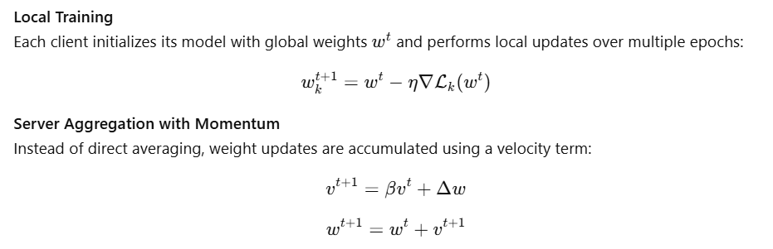
where:
- ΔwΔw is the average client update
- β=0.7β=0.7 is the momentum coefficient
This improves convergence stability and reduces oscillations in heterogeneous environments.

4.4.2 FedProx (Proximal Regularization)
To address client drift in non-IID settings, the FedProx algorithm introduces a proximal term in the local objective:
Lprox=L(w)+μ2∥w−wt∥2Lprox​=L(w)+2μ​∥w−wt∥2
where:
- wtwt is the global model
- μ=0.001μ=0.001 controls the regularization strength
This constraint ensures that local updates remain close to the global model, improving training stability across heterogeneous clients.
Aggregation in FedProx follows standard FedAvg-style averaging.

4.5 Training Procedure
For each task (Phishing, Network Traffic, MNIST), federated training proceeds as follows:
- Initialize global model weights
- For each communication round:
  - Distribute global weights to all clients
  - Perform local training on each client
  - Collect updated weights
  - Aggregate updates (FedAvg++ or FedProx)
  - Update global model
- Evaluate global model across all client datasets
Performance metrics tracked per round include:
- Training Loss
- Training Accuracy
- Validation Loss
- Validation Accuracy

4.6 Gradient Leakage Analysis (MNIST Task)
To evaluate privacy risks, additional gradient-based metrics are computed during federated training:

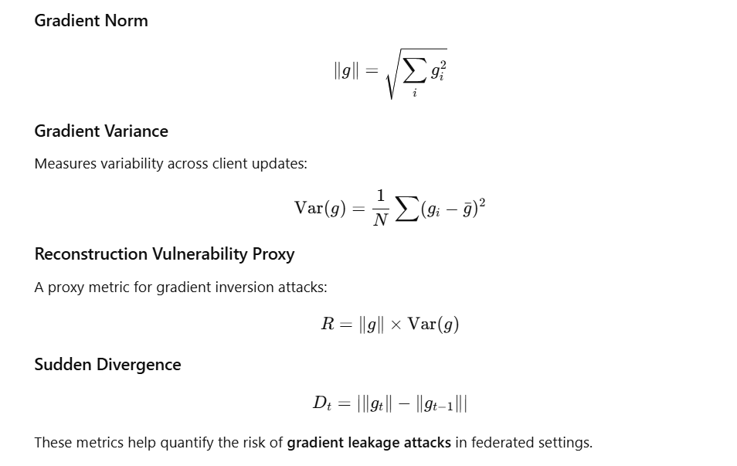
These metrics help quantify the risk of gradient leakage attacks in federated settings.

4.7 Evaluation Strategy
The trained global model is evaluated by aggregating test datasets from all clients:
- Predictions are generated using the global model
- Metrics are computed as weighted averages based on sample counts
- Binary classification uses a threshold of 0.5
Sample-level predictions are also analyzed to verify model behavior.

4.8 Multi-Threat Detection Framework
The system integrates outputs from multiple tasks:
- Phishing Detection
- Network Traffic Analysis
- Gradient Leakage Risk
A combined decision mechanism is used:
Final threat flags are generated using thresholding.

4.9 System-Level Safety Decision
The overall system status is determined based on:
- Presence of phishing attacks
- Detection of malicious network traffic
- Gradient leakage risk exceeding threshold (0.01)

Results

5.1 Performance Metrics
The evaluation is conducted using:
- Accuracy
- Loss (Training & Validation)
- Gradient Norm & Variance (Privacy Analysis)
- Reconstruction Vulnerability Proxy

5.2 Phishing Detection Results

Analysis
The phishing detection model trained using FedAvg++ demonstrates rapid convergence and high classification performance. Training accuracy improves from 56.18% (Round 1) to 99.22% (Round 20), while validation accuracy reaches 98.85%, indicating excellent generalization.
Loss values show a consistent decreasing trend:
- Training Loss: 0.6599 → 0.0230
- Validation Loss: 0.6670 → 0.0366
This indicates:
- Stable learning behavior
- No significant overfitting (train ≈ validation)

FedProx Comparison
FedProx achieves:
- Final Validation Accuracy: 97.15%
- Slower convergence compared to FedAvg++
Key Insight:
FedAvg++ outperforms FedProx in phishing detection due to its momentum-based aggregation, which accelerates convergence and improves global optimization.

5.3 Network Traffic Classification Results

Analysis
For network traffic classification, FedAvg++ shows initial instability due to non-IID data distribution:
- Accuracy fluctuates in early rounds (~72–75%)
- Rapid improvement after Round 6
Final performance:
- Training Accuracy: 94.87%
- Validation Accuracy: 94.76%
Loss stabilizes after mid rounds:
- Validation Loss: 0.6127 → 0.1694
This reflects:
- Sensitivity to heterogeneous client distributions
- Strong late-stage convergence

FedProx shows:
- Much smoother convergence
- Higher final validation accuracy: 97.38%
FedProx performs better in network traffic tasks due to its proximal regularization, which stabilizes training under highly non-IID conditions.

5.4 Gradient Leakage and Privacy Analysis (MNIST)

FedAvg++ Results
The gradient-based privacy analysis shows:
- Gradient Norm: 4.21 → 1.35
- Gradient Variance: 1.39e-4 → 1.7e-5
- Reconstruction Risk: 0.000584 → 0.000023
Observations:
- Rapid decrease in gradient magnitude → model convergence
- Decreasing variance → reduced client update diversity
- Low reconstruction risk → strong privacy preservation
FedProx achieves:
- Lower gradient norms throughout training
- Even smaller reconstruction risk: ~0.000016 (final)
FedProx provides better privacy protection due to constrained local updates via proximal regularization.

5.5 Convergence Behavior Analysis

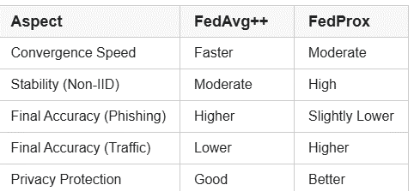

5.6 Comparative Analysis
The comparative evaluation between FedAvg++ and FedProx reveals distinct performance trade-offs. FedAvg++ demonstrates superior convergence speed and higher accuracy in relatively stable tasks such as phishing detection, owing to its momentum-based aggregation strategy. However, in highly heterogeneous environments such as network traffic classification, FedProx achieves more stable and consistent performance due to the incorporation of a proximal term that constrains local model updates. Furthermore, in the context of privacy preservation, FedProx exhibits lower gradient norms and reduced reconstruction vulnerability, indicating enhanced resistance to gradient leakage attacks

5.7 System-Level Security Evaluation
The system integrates outputs from:
- Phishing detection
- Traffic classification
- Gradient leakage monitoring
Final decision:
- If any threat detected → UNSAFE
- Else → SAFE
- Multi-layer threat detection
- Real-world applicability in cybersecurity systems

Phishing

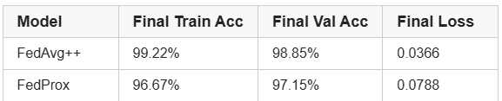

Network
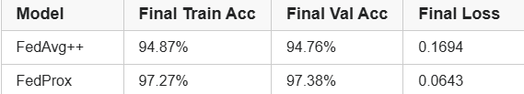

Gradient Leaky:

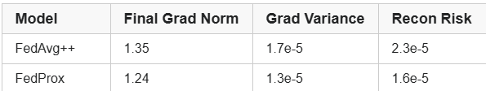

Overall Conclusion:

The experimental results demonstrate that both FedAvg++ and FedProx are effective for federated multi-task learning. While FedAvg++ excels in convergence speed and accuracy for structured tasks, FedProx provides superior robustness and privacy preservation in heterogeneous environments. The integration of gradient leakage metrics further enhances the system’s capability to assess privacy risks, making the proposed framework suitable for secure and scalable federated learning applications.
Overall, the experimental findings reveal that the relative strengths of FedAvg++ and FedProx depend on the application domain. FedAvg++ demonstrated superior performance on the phishing dataset, achieving higher classification accuracy and lower loss. This suggests that it is more effective when rapid convergence and strong predictive performance are prioritized.
On the other hand, FedProx showed clear advantages on the traffic dataset and in the privacy evaluation. Its higher validation accuracy, lower loss, and improved privacy metrics indicate that it is more robust in challenging federated settings, particularly when data distributions are heterogeneous across clients. Therefore, FedAvg++ may be preferred for phishing detection tasks, while FedProx appears more suitable for traffic analysis and privacy-sensitive federated learning applications.

Result Graphs

Phishing results for fedavg++ and fedprox

Fedavg++

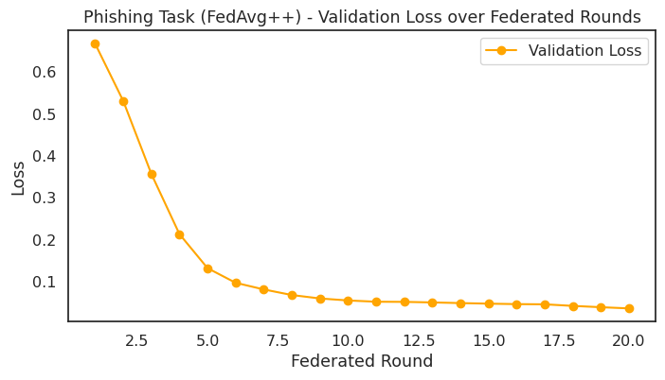
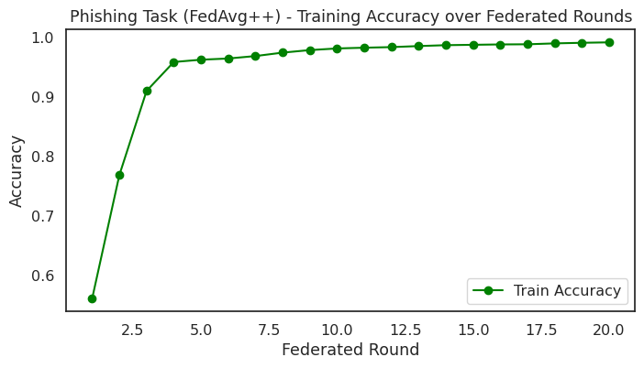
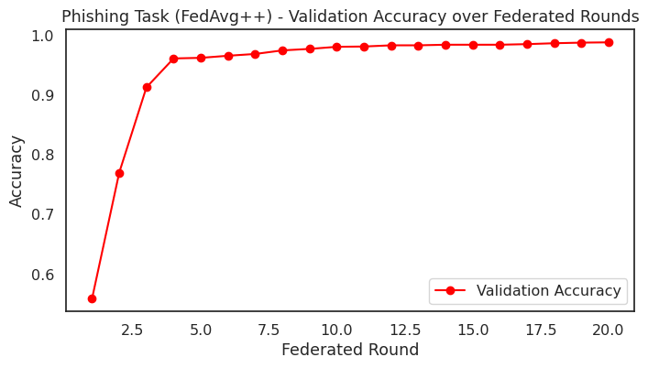

Fedprox

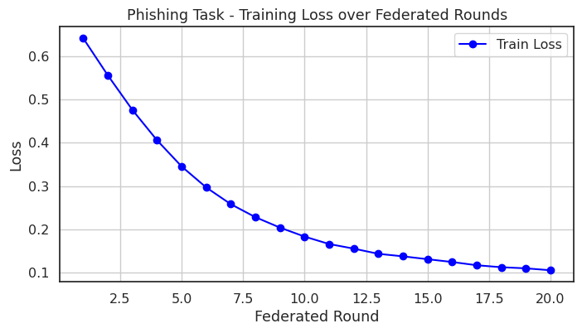

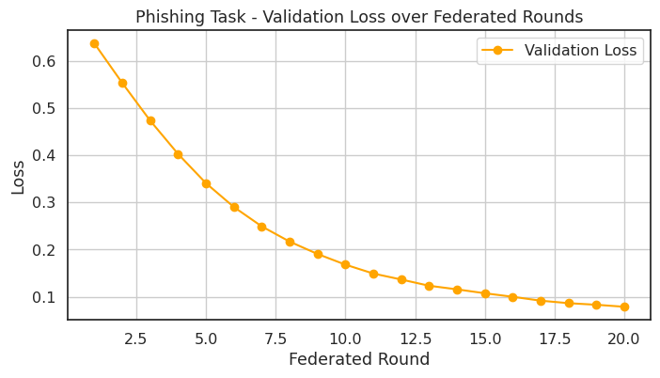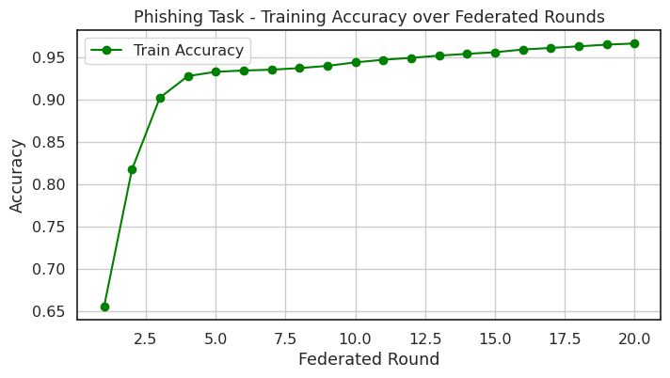

Abnornal results for fedavg++ and fedprox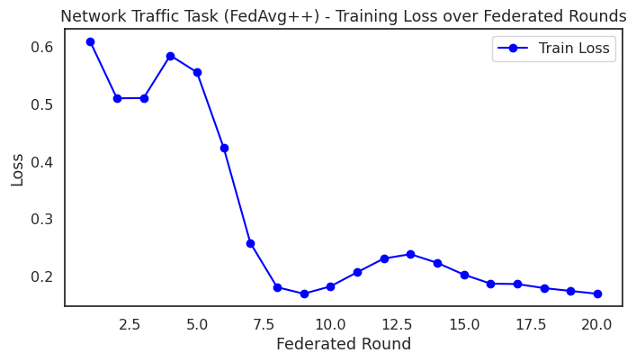
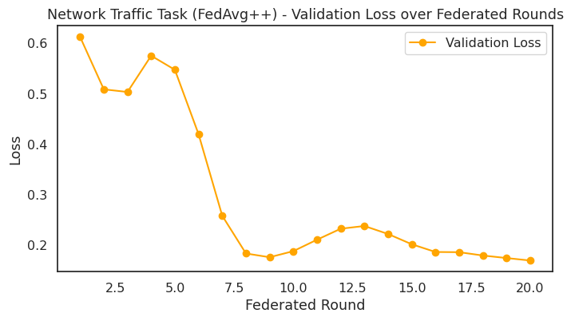



fedprox

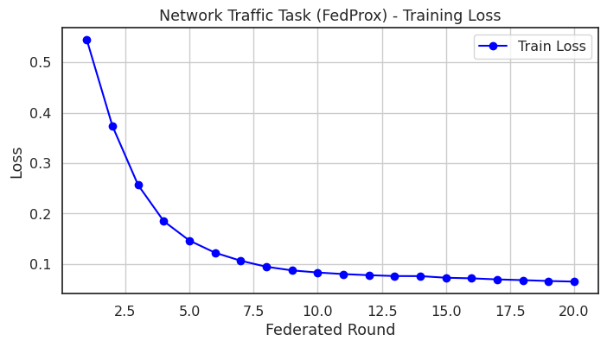

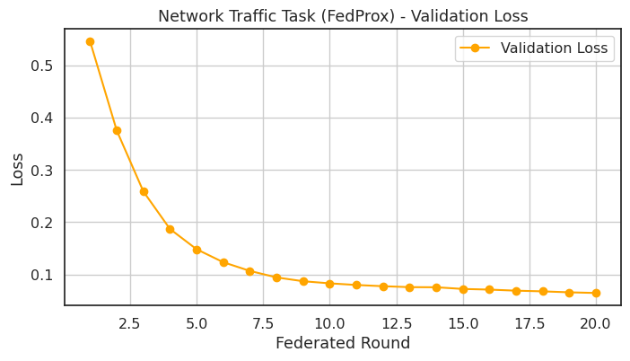

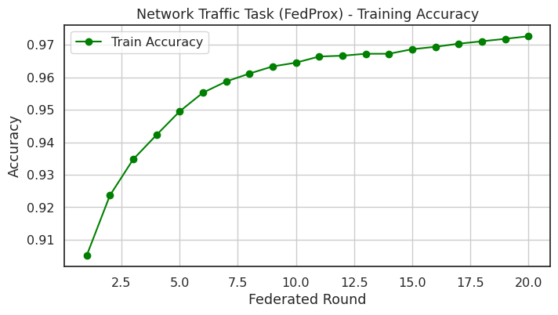

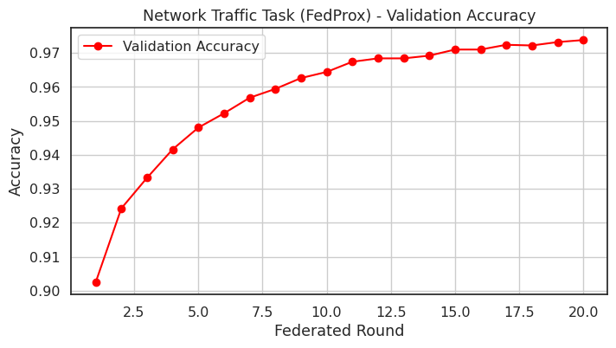

Gradient leakage results for fedavg++ and fedprox

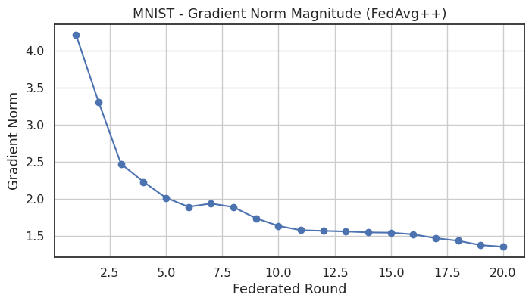

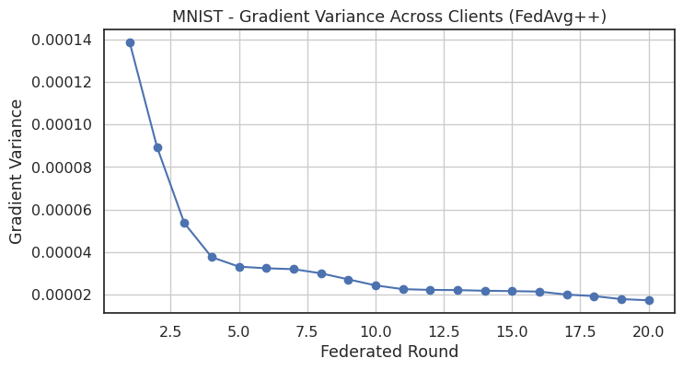
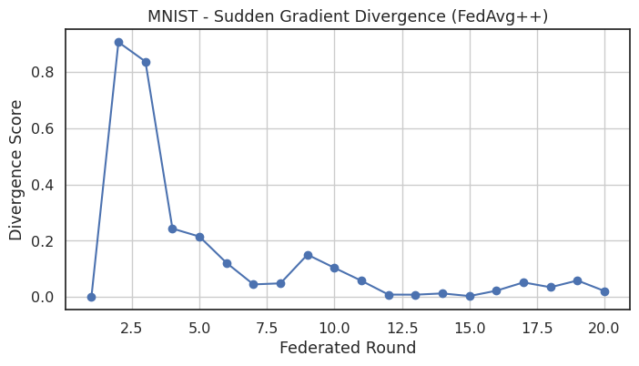

Fedprox

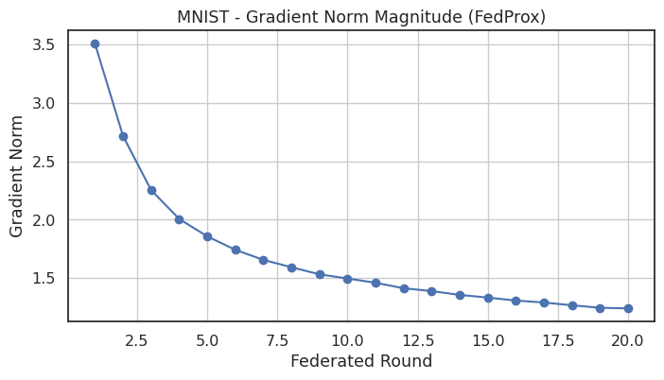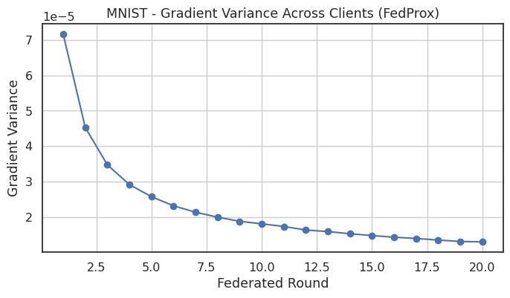

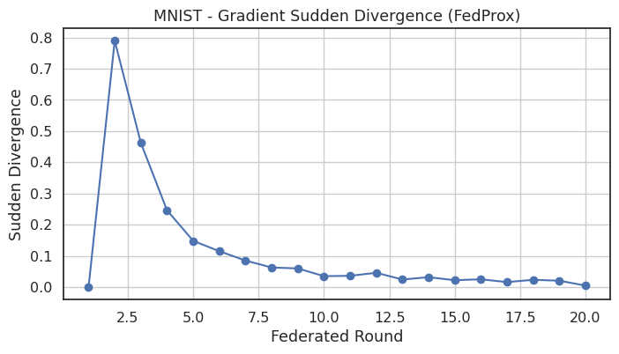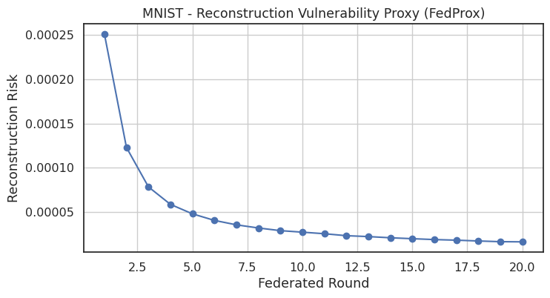

6. Analytical Justification of Results and Methodology

6.1 Justification of Method Selection
The selection of FedAvg++ and FedProx in this study is driven by their complementary strengths in federated learning environments, particularly under heterogeneous and non independent and identically distributed data conditions, which are commonly observed in real world cybersecurity applications.
FedAvg++ is adopted due to its enhanced aggregation mechanism that incorporates momentum based updates. This mechanism accelerates convergence, improves global model generalization, and reduces oscillatory behavior during training. As a result, it is well suited for tasks where faster optimization and efficient learning are required.
In contrast, FedProx is selected for its robustness in handling client level variability. This is achieved through the introduction of a proximal regularization term that restricts large local updates, stabilizes training across diverse clients, and improves performance in highly heterogeneous environments.
The combined use of these two algorithms enables a balanced evaluation framework that captures both rapid convergence characteristics and training stability under non ideal data distributions.

6.2 Justification of Results for Phishing Detection
The phishing detection task demonstrates near ideal convergence behavior, particularly when trained using FedAvg++. The rapid improvement in accuracy, exceeding ninety nine percent, indicates strong feature separability and the effectiveness of preprocessing and feature scaling techniques applied to the dataset.
Furthermore, the minimal difference between training and validation accuracy confirms strong generalization capability and indicates the absence of overfitting. This suggests that the learned model is robust and capable of performing well on unseen data.
The superior performance of FedAvg++ in this task can be attributed to the structured nature of the dataset, which allows momentum based aggregation to efficiently optimize the global objective function.
In comparison, FedProx achieves slightly lower accuracy, which can be explained by the presence of regularization constraints that limit aggressive local updates. While this reduces overfitting risk, it may also slow down convergence in relatively uniform datasets.

6.3 Justification of Results for Network Traffic Classification
The network traffic classification task exhibits different behavior compared to phishing detection, particularly during the initial training rounds. The observed fluctuations in accuracy and loss, especially in the case of FedAvg++, indicate instability during early stages of training.
This behavior can be attributed to the presence of strong non independent and identically distributed data across clients, as network traffic patterns vary significantly across different sources. Such heterogeneity leads to divergence in local model updates when aggregation is performed without constraints.
FedAvg++ is more susceptible to this effect due to unconstrained local updates, which amplify discrepancies between client models. As a result, convergence is delayed until sufficient global alignment is achieved.
In contrast, FedProx demonstrates smoother and more stable convergence behavior. It achieves higher final accuracy due to the proximal term, which effectively mitigates client drift by constraining local updates. This makes FedProx more suitable for heterogeneous environments such as network traffic analysis.

6.4 Justification of Gradient Leakage and Privacy Results
The gradient leakage analysis is conducted to evaluate the privacy preserving capabilities of the proposed federated learning framework. The results indicate a consistent reduction in gradient norm, gradient variance, and reconstruction risk over successive training rounds.
A decrease in gradient norm implies reduced exposure of sensitive information, while lower gradient variance indicates increased consistency in client updates. Additionally, the reduction in reconstruction risk suggests improved resistance to gradient inversion attacks.
FedAvg++ demonstrates strong convergence and a steady decrease in leakage risk. However, its values remain slightly higher compared to FedProx.
FedProx achieves lower gradient norms and reduced reconstruction risk due to the presence of proximal regularization, which constrains the magnitude of updates. This limits the amount of exploitable information in gradients and enhances overall privacy preservation.
These observations confirm that incorporating regularization mechanisms can significantly improve the privacy characteristics of federated learning systems.

6.5 Trade off Analysis Between Performance and Privacy
The results highlight a clear trade off between performance and privacy in federated learning. FedAvg++ provides faster convergence and higher accuracy in structured tasks, making it suitable for scenarios where rapid learning is prioritized.
However, this advantage may come at the cost of slightly higher gradient exposure. In contrast, FedProx offers improved stability and stronger privacy preservation due to constrained optimization, although it converges more slowly.
This trade off demonstrates that the choice of algorithm should be guided by the specific requirements of the application, particularly the balance between performance efficiency and privacy protection.

6.6 Justification of Multi Task Federated Framework
The integration of phishing detection, network traffic classification, and gradient leakage analysis forms a comprehensive and holistic cybersecurity framework. This multi task approach enables the system to detect multiple types of threats while simultaneously evaluating model performance and privacy risks.
Such integration enhances the practical applicability of the framework in real world distributed environments, including edge computing and internet of things systems.
Unlike traditional approaches that focus solely on accuracy, the proposed framework jointly optimizes security, robustness, and privacy, thereby providing a more complete solution for modern cybersecurity challenges.

6.7 Overall Justification
The experimental findings confirm that FedAvg++ is highly effective for tasks requiring fast convergence and high accuracy under relatively uniform data conditions. On the other hand, FedProx is better suited for heterogeneous environments and privacy sensitive applications due to its stability and controlled update mechanism.
The analytical evaluation demonstrates that the selection of federated optimization algorithms has a significant impact on both model performance and privacy characteristics. The proposed dual algorithm framework effectively captures these trade offs and provides a strong foundation for the design of secure and efficient federated learning systems

7. Limitations and Challenges
Despite the promising performance of the proposed federated learning framework, several limitations and challenges must be acknowledged. These limitations primarily arise from the inherent characteristics of federated environments, dataset constraints, and algorithmic trade offs.
One of the primary challenges in this study is the presence of non independent and identically distributed data across clients. Although a Dirichlet distribution is employed to simulate heterogeneity, it may not fully capture the complexity and unpredictability of real world data distributions. This can lead to variations in local model updates and affect global convergence, particularly in the case of aggregation methods without strong regularization.
Another limitation is the restricted number of clients considered in the experimental setup. The system is evaluated using six clients, which, although sufficient for controlled experimentation, may not fully represent large scale federated systems involving hundreds or thousands of participants. As the number of clients increases, issues such as communication overhead, client selection, and system scalability become more significant.
Communication efficiency is also a notable challenge in federated learning systems. The repeated exchange of model parameters between clients and the central server introduces latency and bandwidth constraints. While the current implementation assumes stable communication, real world deployments may experience network delays, partial participation, or client dropouts, which can impact training performance and convergence stability.
The study is further limited by the choice of datasets used for phishing detection and network traffic classification. Although these datasets provide meaningful insights, they may not encompass all possible attack patterns or evolving threat scenarios. Consequently, the generalizability of the model to unseen or emerging cyber threats may be constrained.
In terms of privacy evaluation, the analysis focuses primarily on gradient leakage metrics such as gradient norm, variance, and reconstruction risk. While these metrics provide useful indicators of privacy preservation, they do not capture all possible adversarial attack models. More sophisticated attacks, including adaptive or multi step reconstruction methods, are not considered within the scope of this work.
Algorithmically, a trade off exists between convergence speed and stability. FedAvg++ achieves faster convergence but is more sensitive to client heterogeneity, whereas FedProx improves stability and privacy at the cost of slower optimization. This trade off highlights the challenge of selecting an optimal algorithm that balances performance, robustness, and privacy requirements simultaneously.
Finally, the computational overhead associated with local training on client devices may pose practical challenges. Devices with limited resources may struggle to perform repeated local updates, particularly when dealing with large scale models or high dimensional data. This constraint can affect the feasibility of deploying such systems in resource constrained environments.
In summary, while the proposed framework demonstrates strong performance and effective privacy preservation, addressing challenges related to scalability, communication efficiency, dataset diversity, and advanced threat modeling remains essential for future improvements.

